Retail Sales Analytic Project

Model Design Document (MDD)

Project Overview
This project demonstrates a complete end-to-end Retail Sales Analytics workflow using Python, PostgreSQL, and Power BI. The goal of the project is to transform raw retail transaction data into meaningful business insights through structured data processing and interactive dashboards.

Objective
- Clean and transform raw retail transaction data
- Perform SQL-based analytical transformations
- Build interactive Power BI dashboards
- Generate business insights related to customers, products, and stores

Problem Statement
Retail businesses generate large volumes of transaction data daily. Without structured analysis, it becomes difficult to:
- Identify top-performing products
- Understand customer spending patterns
- Monitor store-level sales
- Track monthly sales trends
- Segment customers based on value
This project aims to transform raw transactional data into business-ready insights using structured data pipelines.

Dataset Description

Dataset Size
- Total Rows: 59,542
- Total Columns: 11
- Time Period: 2023 – 2025
- Customers: 2172
- Stores: 7

Key Columns
- customer_id
- store_name
- transaction_date
- aisle
- product_name
- quantity
- unit_price
- total_amount
- discount_amount
- final_amount
- loyalty_points

Project Architecture
Python → PostgreSQL → Power BI

Data Cleaning & Preprocessing[ Python ]

EDA
Raw retail data was cleaned and transformed using Python.
- Imported raw dataset into Pandas DataFrame
- Displayed first few rows using head()
- Checked number of rows and columns
- Checked dataset shape
- Checked column datatypes
- Generated statistical summary
- Missing Value Handling
Store Name filled with mode
Unit Price filled with mean
- Removed duplicate records
- Data Type Correction
transaction_date → datetime
quantity → integer
price fields → float

Feature Engineering
New columns were created to improve analysis.
- Year : Extracted from transaction_date
- Month : Extracted from transaction_date
- day_name : Derived from transaction_date
- month_year : Formatted for monthly aggregation

Financial Calculations
Calculated financial metrics:
- total_amount = quantity × unit_price
- final_amount = final_amount = total_amount − discount_amount

EDA Visualizations Created

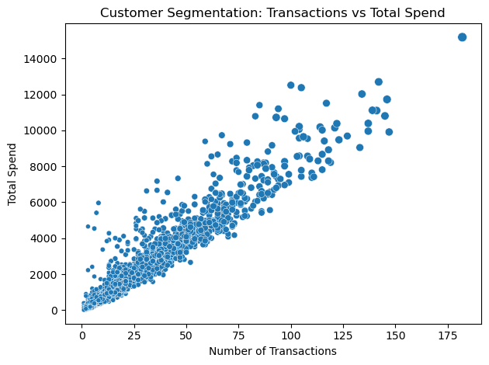Customer Segmentation

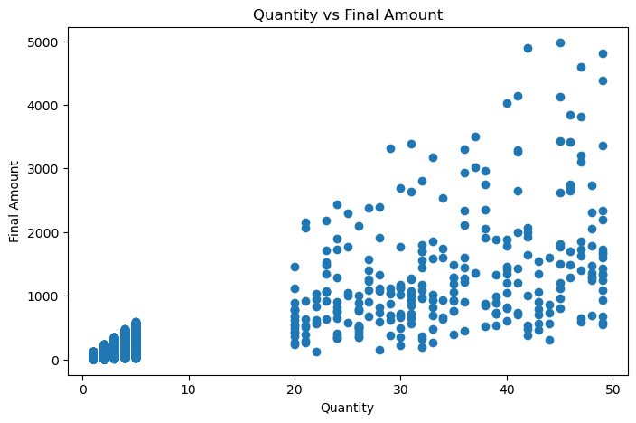
Scatter Graph for Final amount
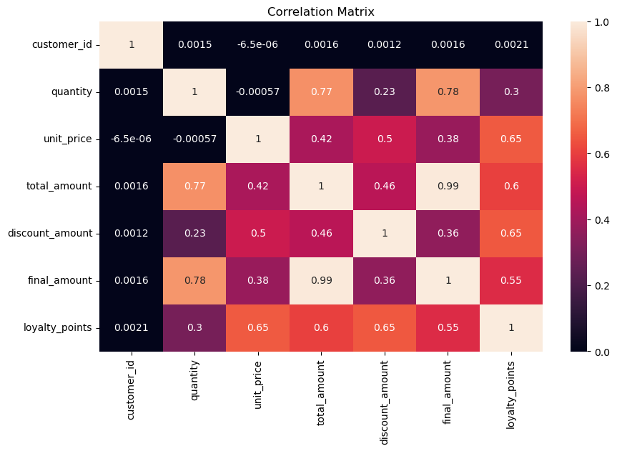
Correlation Heatmap

Database Implementation[ PostgreSQL ]

Database Name : retail_project

Main Table : retail_sales

SQL Tasks Performed:
- Data loading using COPY command
- Aggregation queries
- Group By analysis
- Window function analysis
- Customer-level summary creation

Created SQL Views
- customer_summary_view
To analyze customer-level spending behavior.
- monthly_sales_view
To track monthly revenue trends.
- product_sales_view
To analyze product demand and revenue.
- kpi_summary_view
To generate dashboard KPIs.

Dashboard Development[ Power Bi ]

Page 1 — Overview Dashboard
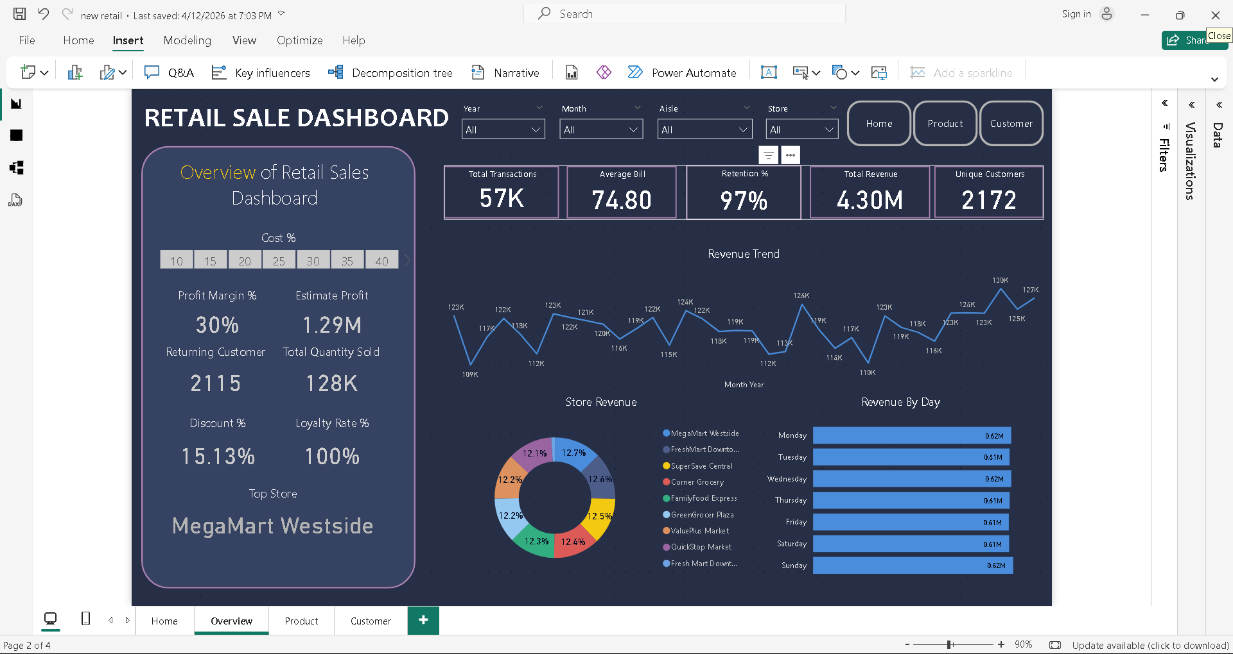

Page 2 — Product Analysis Dashboard
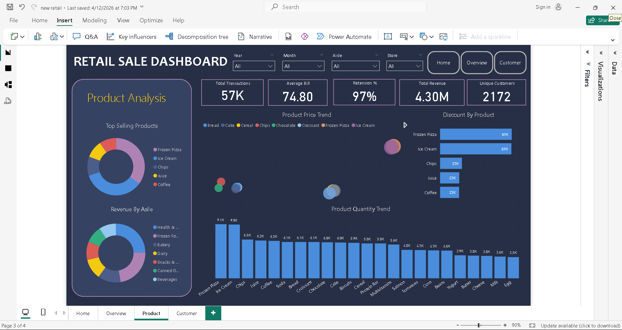

Page 3 — Customer Dashboard
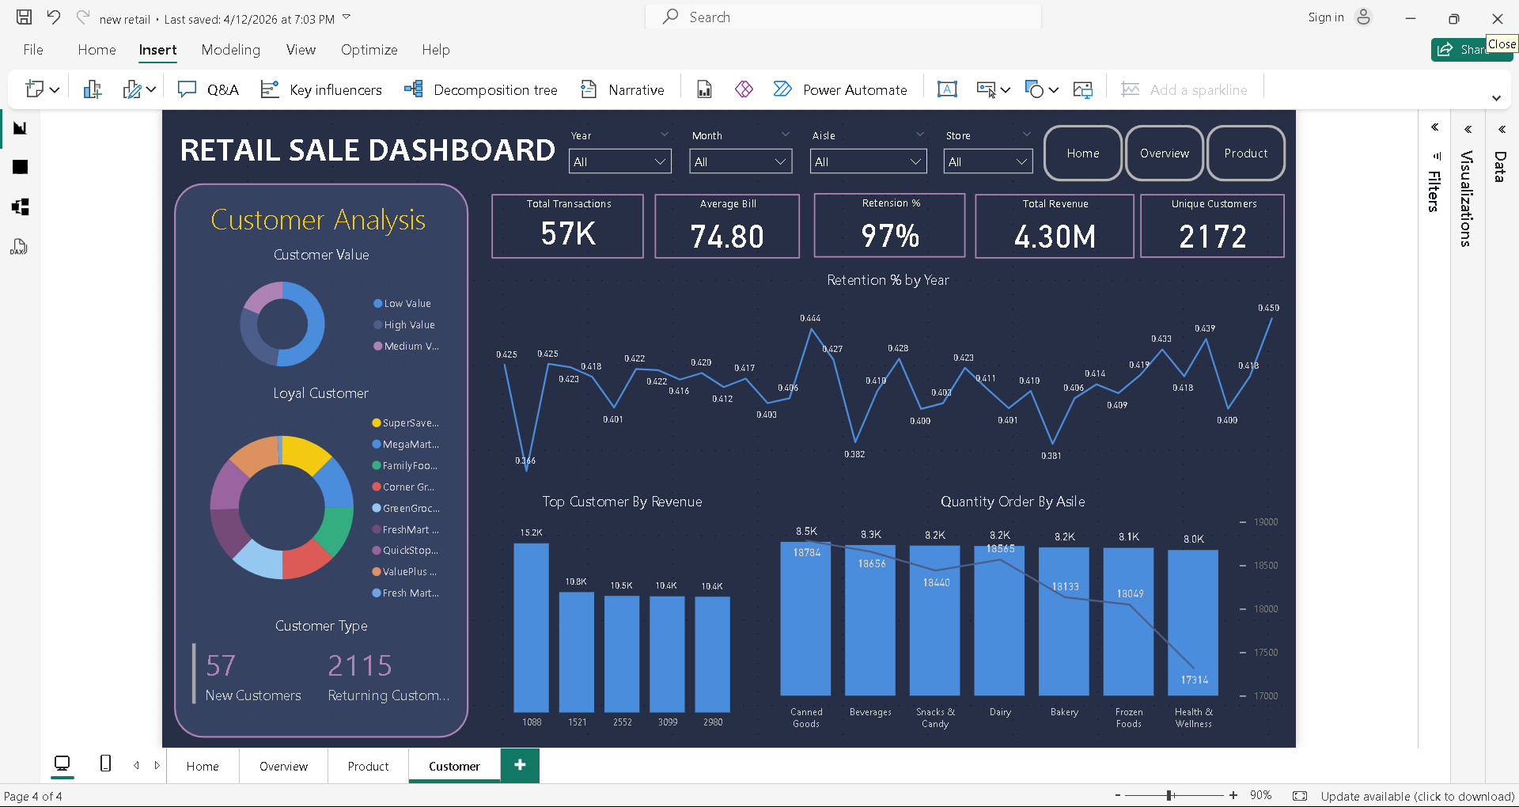

Business Insights Generated
Key insights obtained from the analysis include:
- Identification of high-value customers
- Recognition of top-selling products
- Monthly sales performance trends
- Store performance comparison
- Revenue distribution among customers

Conclusion
This project demonstrates a complete retail analytics workflow from raw data preparation to dashboard visualization.
The final system provides valuable insights into customer behavior, sales patterns, and product performance, supporting data-driven decision-making.

